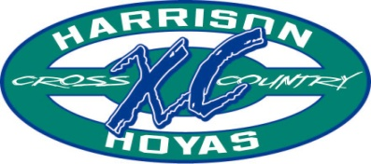

Dear Athletes,

Welcome to Harrison Cross Country. We have a fine tradition of excellence in our program here at Harrison High School. Our teams annually compete for region, county and state championships and our program is widely considered one of the best in the state. The success of our program depends upon the commitment of our athletes, staying healthy, and listening to your coaches.
Summer is the time to build base mileage. Base mileage helps prevent injuries and ensures success during the season. We have created a plan for athletes to follow depending upon their experience, goals, and ability. Please follow the plan that has been created for you. Do not get over-ambitious and try to do too much. We have seen too many people who get injured trying to get into shape in the last two weeks before official practice starts. Our summer runs are low-key opportunities to build that base mileage for the fall, to get to know your teammates, and to become familiar with the sport. Our summer runs will begin on June 13th. Teams (and athletes) that run in the summer win championships in October and November.
Our booster club provides important financial support for all that we do. They coordinate food at all the meets, help provide for the coaching staff, supplement our out of town trip, and host our end of the year banquet. They depend upon volunteers to help coordinate all these activities so encourage your parents to join and volunteer.
The two big events in the summer are great ways to get involved early and to meet your teammates. The Gun’s Up Party is being held at Brookstone Country Club on June 13th and is a great chance to get to know the HHS team. Rising 9th graders may attend the Harrison Running Camp which will be June 6th – 10th.
Thanks for your interest. If you have any questions, please feel free to contact the coaches or the booster club president (Trisha Isaacs). We look forward to a very successful season.

Coach Simmons Coach Scott Cross Country
Co-Head Coach Co-Head Coach Website
Kent.Simmons@cobbk12.org hoyarelay@hotmail.com www.hoyatfxc.com

